**DATA SCIENCE K-MEANS LAB**

**Roll no: 20K-0409**

**Screen Shots**

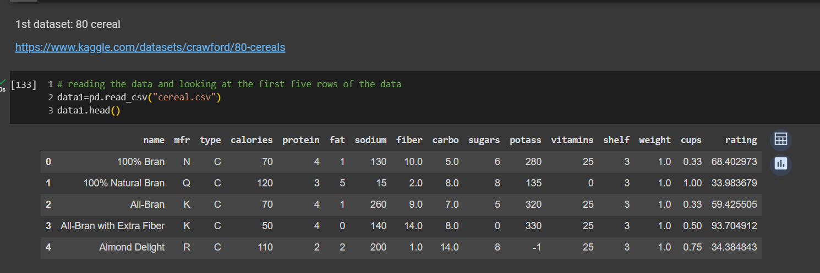**DATAset#1**

**ELBOW graph for cereal dataset , cluster 4**

**DataSet #2**

**Elbow Graph for ground day hog: cluster : 4**

**How will you incorporate the streaming data into your already existing clusters?**

**Using MiniBatchKMeans**

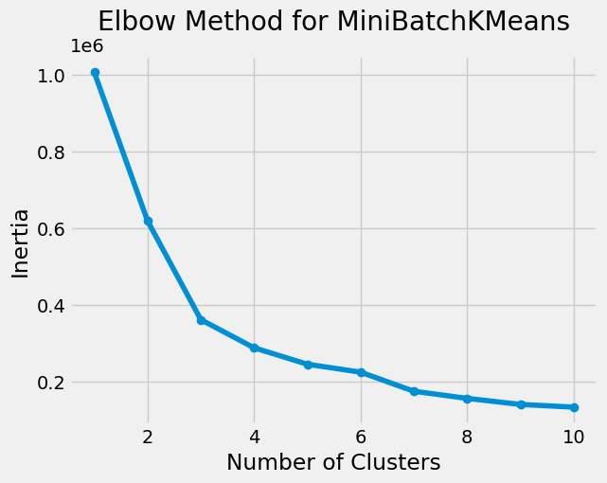**For cereal:**

**For ground day hog:**

